CITADEL FOOTBALL ASSOCIATION
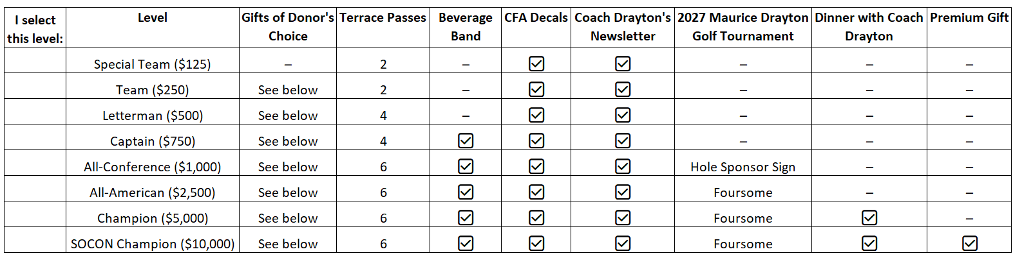
2026 Membership Form
A link will be sent to you via the email address listed below for you to select your Donor’s Choice gifts. If you do not select a gift, your gifts will be chosen for you. Once your gift is chosen, an order/shipping confirmation will be sent to you.

Mark here if no gift is requested
Title: _ __ Name: ___________________ ___________________________ Citadel Class of: ____ ______ Spouse Name: ____________
Circle One: Football Player - Equip. Mgr. - Trainer - Field Mgr. - Video Mgr. - Cheer leader - Player Parent - Past Player Parent - Alumni - Friend
Mailing Address: __________________________________________ City: __ ________ _ State: _____ ___ Zip: _____________ _
Preferred Phone Number: ___ ____________________________ ____________
Email Address: ___________ __________________________ (Required for Newsletters)
Names for Terrace Passes (please refer to above chart for total # of passes for your membership level): _______________________________________________________________________________________________________________________
Life Member: _____________ Check here if Handicapped (For Elevator Access to the Terrace): ________
Please let us know if you are interested in the following: Volunteer Opportunities Nutrition Programs Events Sponsorship Opportunities
Let’s connect on social media! Please let us know your username so we can follow you.
Username on X (formerly Twitter): ________________________________ Username on Instagram: ________________________________
Make checks payable to CFA, write Membership on Memo line and mail to
171 Moultrie Street #67, Charleston, SC 29409
OR
If you prefer your dues to go through the Citadel Foundation for Class Credit,
Make check payable to The Citadel Foundation and write CFA Excellence/Membership on the Memo line. Mail your check to the CFA address above. After we record your membership, we will hand deliver your check to the Foundation. (If you pay directly to The Foundation, CFA is not notified for approximately 30 days.)
QUESTIONS: office@cfabulldogs.com or 843-697-0566
Membership can be purchased online at www.cfabulldogs.com.
Recurring Payments are also available online.

